Node.js Crash Course
Normally we aren’t able to run java script on server side, it’s a front end language which works on browser specifically but with help of node, we can run it on backend ( server-side ) too.
Front end – JavaScript
Back end – Node + Java Script
The machine understand macine code but we cant write machine code easily so we created assembly code but that’s not easy to write either so abstracted it even more and created programming languages and JavaScript is even more abstracted than a normal programming language but computer cant directly compile javascript to machine code directly so we cant run it on computer directly.
But we can run it on browser since behind browser runs an engine called V8 engine, its written in C++ by google and it compiles JS to machine code but JS is confined to brower since there is no V8 engine outside to help with compilation. Node JS program is written in C++ as well which wraps around V8 engine. So we can download V8 and use it outside the browser.
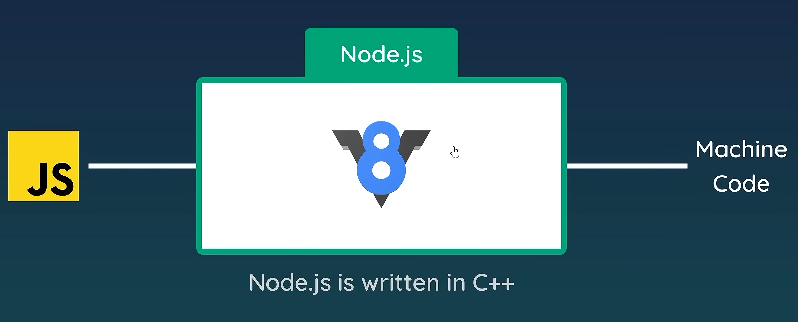

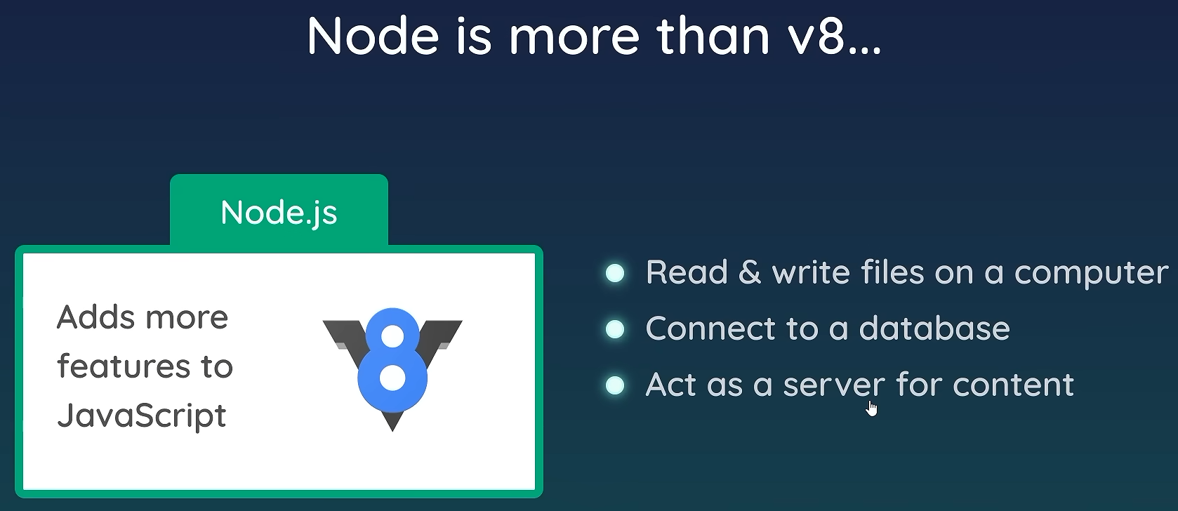
Now with the help of V8 engine, the Node.js goes on top of stack.
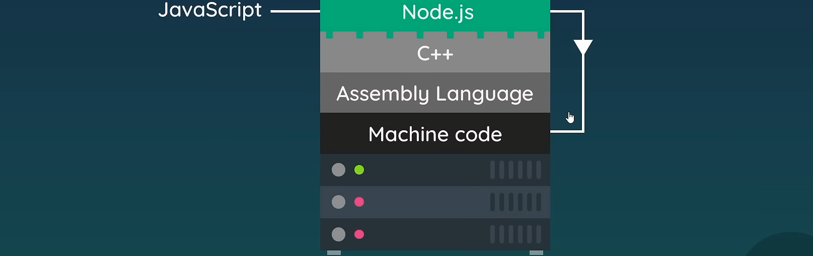
But why use Node.js?
- No need to learn an extra language for the server
- Can share code between the front end and back end
- Node.js has a massive community behind it
- Huge amount of third-party packages and tools to help

So In this course...
- How to install Node.js and use it to run JavaScript
- How to read and write files on your computer
- How to create a server using Node.js to create a website
- How to create an Express app/website
- How to use MongoDB (a NoSQL database)
- How to use template engines to easily create HTML views
- Put everything together to make a simple blog site

Code:-
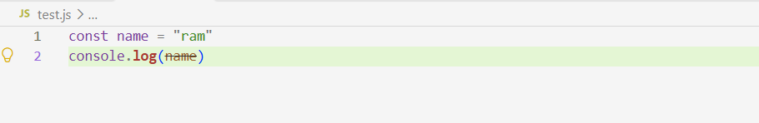
To run this code:-

